GMN Tri-County CAC, Inc.

HEAD START/EARLY HEAD START

ANNUAL REPORT

2017

Office of Head Start logo

This report is prepared to comply with the Head Start Act of 2007 Administrative Requirements and Standards Section 644 [42 U.S.C 9839 (a)(2)].

This institution is an equal opportunity provider.

**GMN Tri-County CAC, Inc. Head Start/Early Head Start**

GMN Tri-County Head Start/Early Head Start (GMN) is a nonprofit organization funded by the United States Department of Health and Human Services (HHS). Since the mid 1960’s, GMN has provided comprehensive early education and development services to income-eligible preschool children, ages 3-5, and their families. An Early Head Start program was added in 2001, to serve pregnant women and children ages 0-3. We prepare children for success in kindergarten and beyond, and provide families with tools for overall success. Our programs are FREE for those who qualify under federal poverty guidelines. Currently, GMN provides services to approximately 428 low-income children and their families at 5 locations throughout Guernsey, Monroe, and Noble Counties.

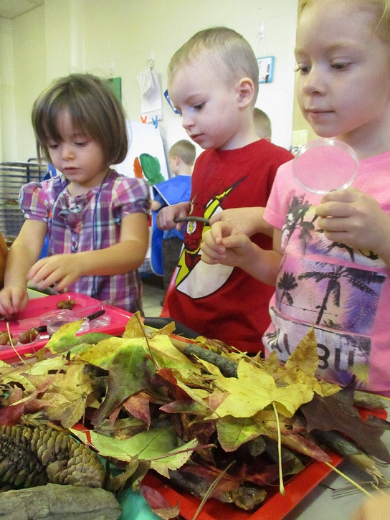

**For Infants, Toddlers and Pregnant Women**

• School Readiness

* Prenatal and postpartum education and support

• Family Engagement: parent/child activities

• Early language and literacy activities

• Nutritious daily meals in the classroom

**For Preschoolers**

• School Readiness (approaches to learning, language and

literacy development, cognitive, physical health and

motor development, problem-solving, social-

emotional development and technology)

• Family Engagement: parent/child activities

• Speech & hearing screening and improvement

• Social service referrals

• Health Screenings

• Nutritious meals daily

* Inclusion and outreach for special populations, including those with special needs and/or disabilities

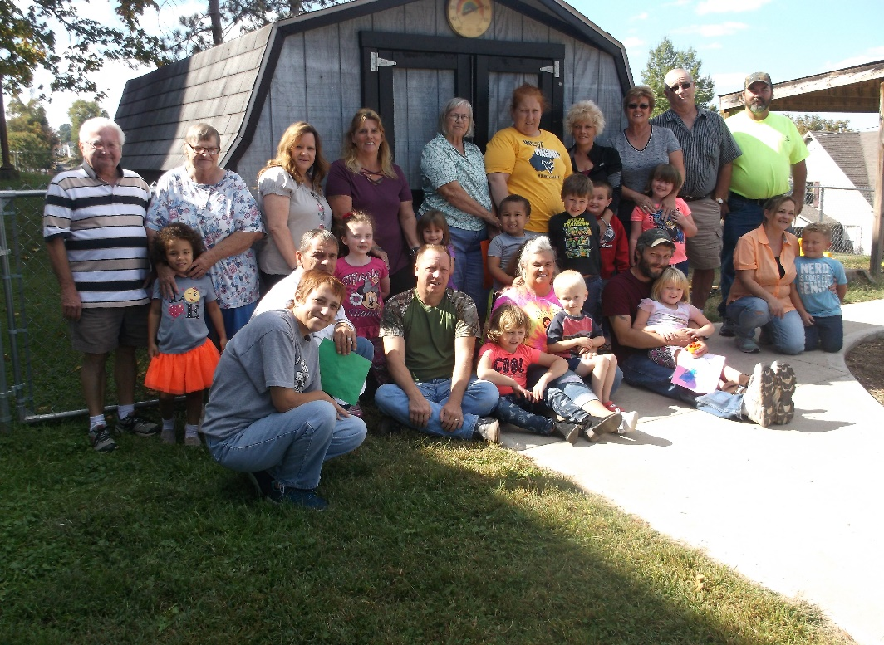

**For Adults**

• Parent engagement/volunteering

• GED preparation

• Parenting group

• Mental Health Consultation

• Male involvement programs

**Special Programs**

• Active Parenting/Parenting Classes/

GMN’s work in the community is enhanced through our collaborations with tri-county area organizations. Community partners include: Guernsey, Monroe, and Noble County Board of Developmental Disabilities, Guernsey, Monroe, and Noble County Department of Job and Family Services, Guernsey, Monroe, and Noble County Health Departments, Ohio Valley Educational Service Center, Noble Learning Center, Local School Districts, local health care and dental care providers, Help Me Grow, COAD, and local Families & Children First Councils.

GMN is governed by an 18-member Board, consisting of government, corporate, and community leaders, and Executive Director, Gary W. Ricer.

**Responding to the Needs of Our Community**

More than just an early care and education program, GMN Head Start and Early Head Start are committed to being a School Readiness Program by delivering “whole family” services. Our primary goal is to assist the families we serve in achieving and maintaining total self-sufficiency. We offer parent/child activities to do in the home, GED preparation and job skills training.

GMN’s Fatherhood Program engages fathers, grandfathers, uncles, guardians and any other significant male figures who are involved in the lives of Head Start/Early Head Start children. Designed to increase male involvement in our classrooms, the focus of this initiative is to empower fathers to make better choices that will ultimately improve the quality of their lives and positively impact the lives of their children. In addition to bringing them into the classroom, the Fatherhood Program helps men locate resources for job/training opportunities and for resolving child custody and child support issues. A key component of this effort is creating successful strategies for single and/or estranged dads to improve relationships with the mothers of their children.

**Striving Toward Our Goals for Excellence**

To ensure compliance with federal regulations, GMN Head Start and Early Head Start undergo several Federal Reviews throughout the five year grant period. There are more than 300 standards to which we must adhere. The HS/EHS Programs also conduct a Self - Assessment each year.

Four out of five Head Start/Early Head Start centers are rated through “Step Up To Quality”, Ohio's voluntary quality rating system for ODE & ODJFS licensed child care programs. “Step Up To Quality” recognizes early care and education programs that exceed quality benchmarks over and above Ohio's licensing standards. One of our sites, plus our partnership site are Rated Five Stars; the highest rating possible with (formerly Step Up To Quality)!

**Impact on Guernsey, Monroe, and Noble Counties**

• Federal Head Start and Early Head Start grants bring in over **$3 million** to the tri-county economy.

• GMN HS/EHS generates over **$1,352,041** in local community in-kind contributions.

• More than **68** individuals volunteered in GMN Head Start/Early Head Start centers.

• GMN HS/EHS employs and/or contracts with **115** individuals.

• GMN funding per child for program operations was **$7,394.29** for Head Start and $**8,593.45** for Early

Head Start.

*“The question is not whether we can afford to invest in every child; it is*

*whether we can afford not to.”*

Marian Wright Edelman

**GMN Head Start/Early Head Start Programs**

**Program Characteristics**

• GMN provides services at 5 locations throughout the tri-county area.

• During the 2016-2017 school year, GMN’s combined funded enrollment for Head Start and Early Head

Start was **428.** In actuality, we served **560,** which includes 534 children and 26 pregnant women.

• Of the Head Start slots funded, **90%** were in our center-based, four day a week classes and **10**% were

served through our FD/FY child care partnership which is five days a week.

• Of the Early Head Start slots funded, **23%** were in our five day a week, center-based classes at our

partnership and **74%** were in our home-based option (children and pregnant women).

• Average monthly enrollment in Head Start and Early Head Start was **99.4%**

(based on funded enrollment numbers from August 2016 through July 2017.)

**Of the families served in 2016-2017:**

• 93.4% of GMN HS/EHS Children/Pregnant women are White.

• 4.1% of GMN HS/EHS Children/Pregnant women are Biracial/Multi-racial.

• 2.33% of GMN HS/EHS Children/Pregnant women are Black or African American.

• .17% of GMN HS/EHS Children/Pregnant women are Asian or Unspecified.

**Head Start/Early Head Start**

**Enrollment by Eligibility**

**408 Below 100% of Poverty**

**74 TANF, SSI**

**47 Foster Care**

**1 Homeless**

**30 Over Income**

**Family Engagement and other volunteer activities include:**

* *Fatherhood activities
* *Family Visitation Day
* *Day with Dad
* *Grandparent’s Day
* *Celebrating with Siblings
* *Family Cook Out
* *Field Trips
* *Classroom Visitors
* *Literacy Days
* *Parent Meetings
* *Policy Council
* *Fatherhood Events
* *Mommy and Me Events
* *Classroom Volunteers
* *Center Volunteers
* *Family Service Volunteers
* *Recruitment Volunteers
* *Ohio Works First Volunteers

**140** parents participated in a Family Engagement Event or in other activities.

**Characteristics of Head Start/Early Head Start Staff**

**Of the 115 contracted and employed GMN HS/EHS staff:**

• Over **46%** are former or current Head Start parents.

• 45GMN HS/EHS employees / contracted staff are Teachers, Parent Educators or Teacher Assistants.

* **33.3%** of GMN Teachers and Parent Educators have a Bachelor Degree or higher in early childhood education or a related field.
* **40**% of GMN Teachers and Parent Educators have an Associate Degree in early childhood education or a related field.

• **8.8%** of GMN Teachers, Parent Educators or Teacher Assistants are enrolled in Early Childhood Education college courses.

**Health Outcomes for Children and Pregnant Women**

Many good things happen for children and pregnant women participating in GMN Head

Start/Early Head Start programs. While the Program Information Report does not track all accomplishments, it does track key benefits, including:

* **100%** of Head Start and Early Head Start children and **100%** of pregnant women had health insurance.
* **100%** of Head Start and Early Head Start children had a medical home by the end of the enrollment year.
* **100%** of pregnant women received prenatal education on fetal development and the benefits of breastfeeding.
* **92.5%** of children were up-to-date on a schedule of age-appropriate preventive and primary health care.
* **35%** of pregnant women enrolled in EHS received both prenatal and postpartum health care.
* **60%** of all Head Start children ages 3 - 5 completed a dental exam.
* **95%** of Early Head Start enrollees are up-to-date on a schedule of age-appropriate oral health care.
* **8%** of Early Head Start pregnant mothers received a professional dental exam and/or treatment.

**HEAD START END OF YEAR CHILD OUTCOMES REPORT FOR 2016-2017**

The GMN Tri-Co CAC Head Start program used the Galileo On-line Assessment to document and report child progress and growth. The Galileo Scales used by the Head Start program were chosen because they correlate with both the Head Start Federal Outcomes and the Early Learning Content Standards for Ohio. Children are assessed in six areas:

|  |
| --- |
| **GMN HEAD START/EARLY HEAD START SCHOOL READINESS GOALS/AGES 0-5** |
| **Approaches to Learning**  Goal 1: Children will demonstrate persistence and maintain interest when working with materials and/or engaging in activities |
| Goal 2: Children will explore and participate in daily interactions and activities to demonstrate eagerness to learn, ability to create and gaining increasing independence |
| **Current EHS Goals connected to this area:**   * Explores most areas of the classroom * Participates independently in an increasing variety experiences |
| **Social and Emotional Development**  Goal 3: Children will be able to regulate emotional responses, express their feelings appropriately and participate cooperatively in group situations |
| Goal 4: Children will learn to follow classroom rules, routines and directions |
| **Current EHS Goals connected to this area:**   * EHS Child will be able to play beside another child for short periods of time. * EHS Child will show interest in toilet training. |
| **Language and Literacy**  Goal 5: Children will identify letters of the alphabet and utilize in meaningful ways |
| Goal 6: Children will write for a variety of purposes and demonstrate aspects of print convention |
| Goal 7: Children will use receptive and expressive language for conversation and communication |
| **Current EHS Goals connected to this area:**   * EHS child will be able to combine words to create meaningful short sentences |
| **Cognition & General Knowledge**  Goal 8: Children will use math in daily routines to count, compare, relate and identify patterns |
| Goal 9: Children will use observation, prediction, questioning and develop hypotheses to gain information and increase their understanding of their surroundings |
| **Current EHS Goals connected to this area:**   * Sorts objects (e.g. Beads) by color or by size * Uses spoon to get food into her/his mouth |
| **Perceptional Motor and Physical Development**  Goal 10: Children will demonstrate control of large motor skill in movement and balance |
| Goal 11: Children will demonstrate control of small motor skills during self-care and beginning writing |
| Goal 12: Children will demonstrate an understanding of healthy and safe habits |
| **Current EHS Goals connected to this area:**   * Uses language to communicate with parents, caregivers, teachers and peers |
| **Health**  Goal 13: Children’s health concerns will be identified in a timely manner and treated effectively in the following areas: well child visits, vision/hearing screenings, immunizations, dental exams, medical/ dental homes |
| **Current EHS Goals connected to this area:**   * EHS child will be up to date on well child exams * EHS child will be up to date on immunizations * EHS child will have completed Lead and Hct/Hgb * EHS child will have completed dental exam * EHS child will have completed hearing and vision screenings |

**CLASS**

The Classroom Assessment Scoring System (CLASS) was completed on the GMN Head Start classrooms. The assessments were completed internally by the GMN Education Manager in the spring of 2016-2017 (April/May). All classroom scores were averaged for the program results. The average scores were:

Score (2015-2016) (2014-2015) (2013-2014) Goal

Emotional Support: 6.65 6.25 5.87 5.92 5.00

Classroom Organization: 6.58 6.01 5.58 5.684.00

Instructional Support**:**  4.84 3.86 3.67 3.61 3.00

HS teaching staff attended training on CLASS Instructional Supports in 2016-2017. The GMN Education Manager will continue to complete CLASS on all GMN Head Start classrooms in the 2017-2018 school year. A Coach/Mentor was contracted to provide support to HS teaching staff. CLASS is not conducted on EHS classrooms.

|  |
| --- |
| **Most Recent Federal Monitoring Reviews**  GMN Head Start and Early Head Start had two Monitoring Reviews conducted by Administration for Children and Families (ACF) during the 2015-2016 program year. A Comprehensive Services/ School Readiness Review took place on 10/13/15-10/15/15: no area of noncompliance was found during the course of the review. A Leadership/ Governance/Management Systems Review took place on 5/263/16-5/27/16: no area of noncompliance was found during the course of the review. GMN HS and EHS were not due for monitoring reviews in the 2016-2017 program year. |

**HEAD START/EARLY HEAD START**

**Total Funds Received**

Cash Non-Cash

Department of Health and Human Services $3,381,675.00

Department of Agriculture - (USDA) $ 139,793.09

DS-Start Up 5,630.00

In-Kind $1,352,041.78

Sale of Buses/Materials 2,073.50

SUTQ 4,000.00

Total Resources Available $3,533,171.59 $1,352,041.78

**Proposed use of funds and actual use of funds for FY 2016-2017:**

Budget Expenditures

Personnel $1,723,221.00 $1,588,942.05

Fringe Benefits $ 614,657.00 $ 647,271.97

Out-of-Area-Travel $ 3,350.00 $ 4,689.05

Supplies $ 132,113.00 $ 187,497.76

Contractual $ 489,908.00 $ 458,304.09

Other $ 365,427.00 $ 392,096.65

T/TA $ 58,629.00 $ 58,629.00

SUTQ $ 4,000.00 $ 4,000.00

**Audit Report Summary**

R C Conley & Company was selected to complete a financial audit of the GMN Tri-County Community Action Committee, Inc. for the period ending July 31, 2016. The audit was completed with the following results. There were no findings related to the financial statements in accordance with generally accepted governmental auditing standards. Also, there were no findings and questioned costs relating to federal awards.

**GMN Tri-County CAC, Inc.**

**TOTAL AGENCY FUNDING BY SOURCE 08/01/16 – 07/31/17**

**DEPARTMENTS**

HEAD START/EARLY HEAD START $3,393,378.50

USDA (HEAD START ONLY) $139,793.09

HEAP $1,114,960.00

HOUSING/OHTF $450,373.00

SENIOR $616,000.00

CSBG/CDBG/EFSP/PIPP $525,770.00

PREVENTION/TRUST $473,980.00

BROADBAND $435,000.00

HCRP $182,500.00

**TOTAL FUNDING: $7,331,754.59**